H.T No
Regulations:
A15

Sreenidhi Institute of Science and Technology
(An Autonomous Institution)
Code No: 5C746 Date: 18-Mar-2021 (FN)

B.Tech IV-Year I- Semester External Examination, March/April - 2021 (Supplementary)
MIMO OFDM SYSTEMS (ECE)

Time: 3 Hours Max.Marks:75

Note: a) No additional answer sheets will be provided.
b) All sub-parts of a question must be answered at one place only, otherwise it will not be valued.
c) Missing data can be assumed suitably.

ANSWER ANY 5 OUT OF 8 QUESTIONS. EACH QUESTION CARRIES 15 MARKS.

Bloom's Cognitive Levels of Learning (BCLL)

Remember | L1 | Apply | L3 | Evaluate | L5
Understand | L2 | Analyze | L4 | Create | L6

 |  |  | BCLL | CO(s) | Marks
1. | a) | Analyze the effect of multipath components. | L4 | CO1 | [8M]
 | b) | Derive the expression for Rayleigh density. | L3 | CO1 | [7M]
2. | a) | Analyze the multicarrier communication system (transmitter & receiver). | L4 | CO2 | [8M]
 | b) | Analyze the impact of cyclic prefix on data rates. |  | CO2 | [7M]
3. | a) | Consider an L = 2 receive antenna wireless channel with complex fading channel coefficients 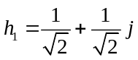, 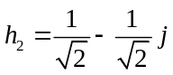. Describe the system model for the multi-antenna channel and derive the SNR with MRC. | L3 | CO3 | [8M]
 | b) | Derive the Bit Error Rate equation for Multi antenna systems. | L3 | CO3 | [7M]
4. | a) | Derive the expression for estimated data for MIMO MMSE receiver. | L3 | CO4 | [8M]
 | b) | Derive the capacity of MIMO SVD system. | L3 | CO4 | [7M]
5. | a) | Analyze the processing at the transmitter and the receiver for the given system 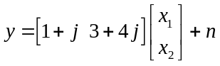 with the Alamouti code. | L4 | CO5 | [8M]
 | b) | describe the various stages of the V-BLAST receiver for the 2 x 2 MIMO system whose channel matrix, 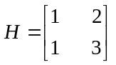 | L3 | CO5 | [7M]
6. | a) | Explain the key technologies used in 5G? | L2 | CO6 | [8M]
 | b) | Briefly explain about massive MIMO technology | L2 | CO6 | [7M]
7. | a) | Analyze the impact of fading on system performance. | L4 | CO1 | [5M]
 | b) | Explain the concept of multi carrier. | L2 | CO2 | [5M]
 | c) | Evaluate the diversity gain of the SIMO system implemented with Maximum Ratio combining. | L3 | CO3 | [5M]
8. | a) | Compute the SVD of the following 3 × 2 channel matrix 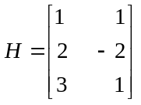 | L3 | CO4 | [5M]
 | b) | Explain how independent data is transmitting in parallel in V-BLAST. | L2 | CO5 | [5M]
 | c) | Discuss various advantages of 5G technology. | L2 | CO6 | [5M]

-- 00 -- 00 –

